EENG 385 - Electronic Devices and Circuits

Lab 3 - Deboo Integrator

Just The Solutions

# Objective

The objective of this lab is to introduce you to the operation of the Deboo Integrator and its interactions with 555 Timer and Schmitt Trigger Relaxation Oscillator to create a staircase voltage waveform.

# System Architecture

Table : The output of the 555 Timer and Schmitt Trigger Oscillator simulations from the prior two labs.

|  |  |  |
| --- | --- | --- |
| Quantity | 555 Timer Simulation | Schmitt Trigger Relax Osc Simulation |
| Time high (us) | 39.0 us | 0.47ms |
| Time low (us) | 275 us | 6.48ms |
| Period (us) | 314 us | 6.95ms |
| Frequency (kHz) | 3.18 kHz | 144Hz |
| Duty Cycle | 12.4% | 6.8% |

# Analysis Deboo Integrator

1. Write an equation relating V- and Vout. Solve in terms of Vout. Hint, voltage divider.

**Vout = 2*V-**

1. Write an equation for Iout in terms of V+, Vout and R. Hint, use Ohm’s law.

**(Vout – V+) = IoutR Iout = (Vout – V+)/R**

1. Replace the Vout term in the step 2 equation with the value for Vout found in the step 1 equation.

**Iout = (2*V- – V+)/R**

1. Since the circuit has positive/**negative** feedback the inverting and non-inverting inputs of the op amp are the same. Let’s call this common voltage Vc. So V- = V+ = Vc.
2. Replace V+ and V- in the step 3 equation with Vc. Simplify.

**Iout = (2*Vc – Vc)/R = Vc/R**

1. Write an equation for Iin in terms of Vin, Vc and R. Hint, Ohm’s law.

**(Vin – Vc) = IinR so, Iin = (Vin – Vc)/R**

1. Write a KCL equation for the V+ node.

**Iout + In = Ic**

1. Replace the Iout and In terms in the step 7 equation with the value for Iout/Iin found in the step 5/6 equation. Simplify. Hint, the simplified equation has three terms.

**Vc/R + (Vin – Vc)/R = Ic so, Vin/R = Ic**

1. Write the equation for the current (called Ic) in a capacitor in terms of the voltage (called Vc) and capacitance.

**Ic = C dVc/dt**

1. Replace the Ic term in the step 9 equation with the value for Ic found in the step 8 equation.

**CdVc/dt = Vin/R**

1. Replace the Vc term in the step 10 equation with the value of Vc found in the step 1 equation (remember that V- equals Vc).

**CdVout/2dt = Vin/R**

1. Multiply both side of the step 10 equation by dt/C and then integrate both sides.

**dVout = (2Vin/RC)dt so, Vout(t) = 2/RC * Integral { Vin(t) } from time 0 to t**

# Analysis Deboo Integrator in BJT Curve Tracer

1. Using the values of resistance and capacitance in Figure 1, compute the weighting factor 2/RC for the Deboo Integrator output. Note we will not be including capacitor C7 in our design today. So ignore it in the analysis.

**From Figure 1, R = 6.8k and C = 0.1uF, so 2/RC = 2,941/sec**

1. Assume that Vcc = 9V. Apply a single 555 Timer pulse from Table 1 to the Vin terminal of the Deboo Integrator. How much will Vout increase? Remember that the integral is the area under the curve and for the 555 Timer pulse, this is just the area of the rectangle formed by the pulse. Put this value in the Analysis column of Table 2 in the Analysis section at the end of the lab.

**Vout(t) = 2/RC * Integral { Vin(t) } from time 0 to t**

**Vout(t) = 2941 * Integral { Vin(t) } from 0 to 39us = 1.03V**

1. Assume that the Vout of the Deboo Integrator is initially at 0V as shown in the upper graph of Figure 3. The lower graph shows a sequence of pulses from the 555 Timer being applied to the input of the Deboo Integrator. Draw the resulting voltage vs. time graph of the Vout.

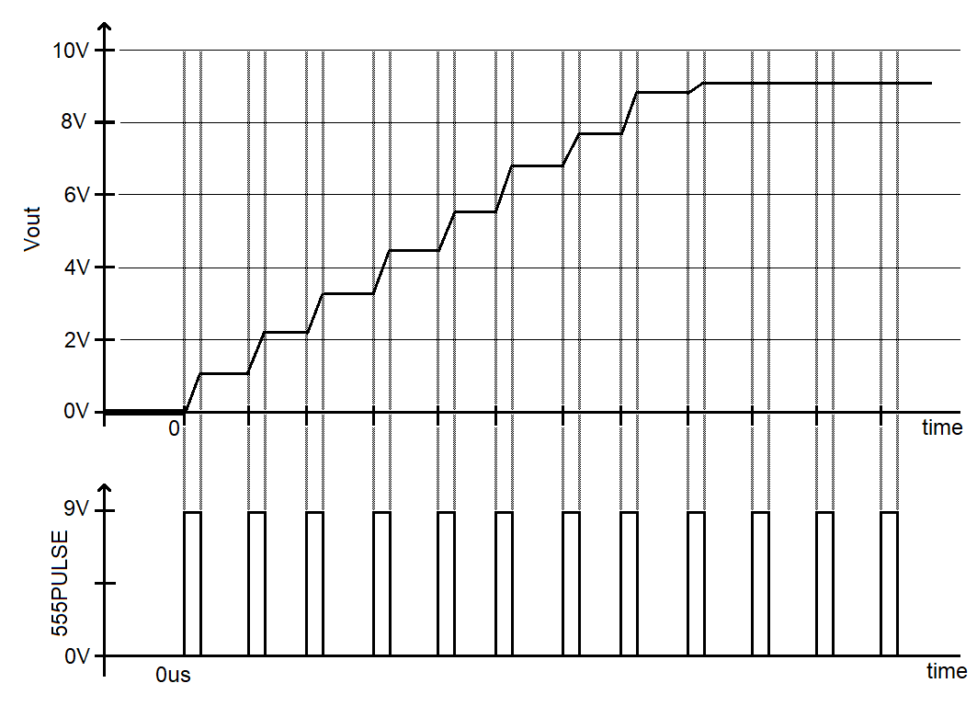

Figure : Complete the Vout curve that is generated by the Deboo Integrator circuit when the 555 pulse train is applied.

1. What circuit (subsystem name) is supplying the signal applied to the base of Q1?

**The Schmitt Trigger Relaxation Oscillator drives the base of Q1.**

1. During on period, how long is the FRAME signal at 0V and how long is FRAME at 9V?

**FRAME stays low for 6.48ms and goes high for 0.47ms.**

1. About how many (integer)555 Timer pulses arrive at the input of the Deboo Integrator while the base of transistor, FRAME, is at 0V?

**The 555 Timer has a period of 314us. So, there are 6480us/314us = 20 or 21 Timer pulses while the FRAME signal is at 0v?**

1. When the base of Q1 is driven towards 9V, what will happen to the capacitor C5? Will it be discharged or allowed to accumulate charge?

**When the base of Q1 is driven towards 9V, capacitors C5 will be discharged.**

1. When the base of Q1 is driven towards 0V, what will happen to the capacitor C5? Will it be discharged or allowed to accumulate charge?

**When the base of Q1 is driven towards 0V, capacitors C5 will be allowed to charge.**

1. Using the information, you calculated in this section, estimate about how long will the Deboo Integrator output will be saturated at 9v?

**Since each 555 Timer pulse increases the voltage of the Deboo Integrator by 1.03V, it will take 9V/1.03V = 9 steps to increase the Deboo Integrator output to 9V. Each 555 Timer pulse is 314us, so this will require 9*314us = 2.83ms.**

**The Schmitt Trigger Relaxation Oscillator is at 0V for 6.48ms. For 2.83ms of this time, the Deboo Integrator output will be “climbing” the stairs. For 6.48ms – 2.83ms = 3.65ms the Deboo Integrator output will be saturated at the top stair.**

# Simulation Deboo Integrator

After building the circuit, run the simulation for 20ms and include the simulated waveform with in your answers.

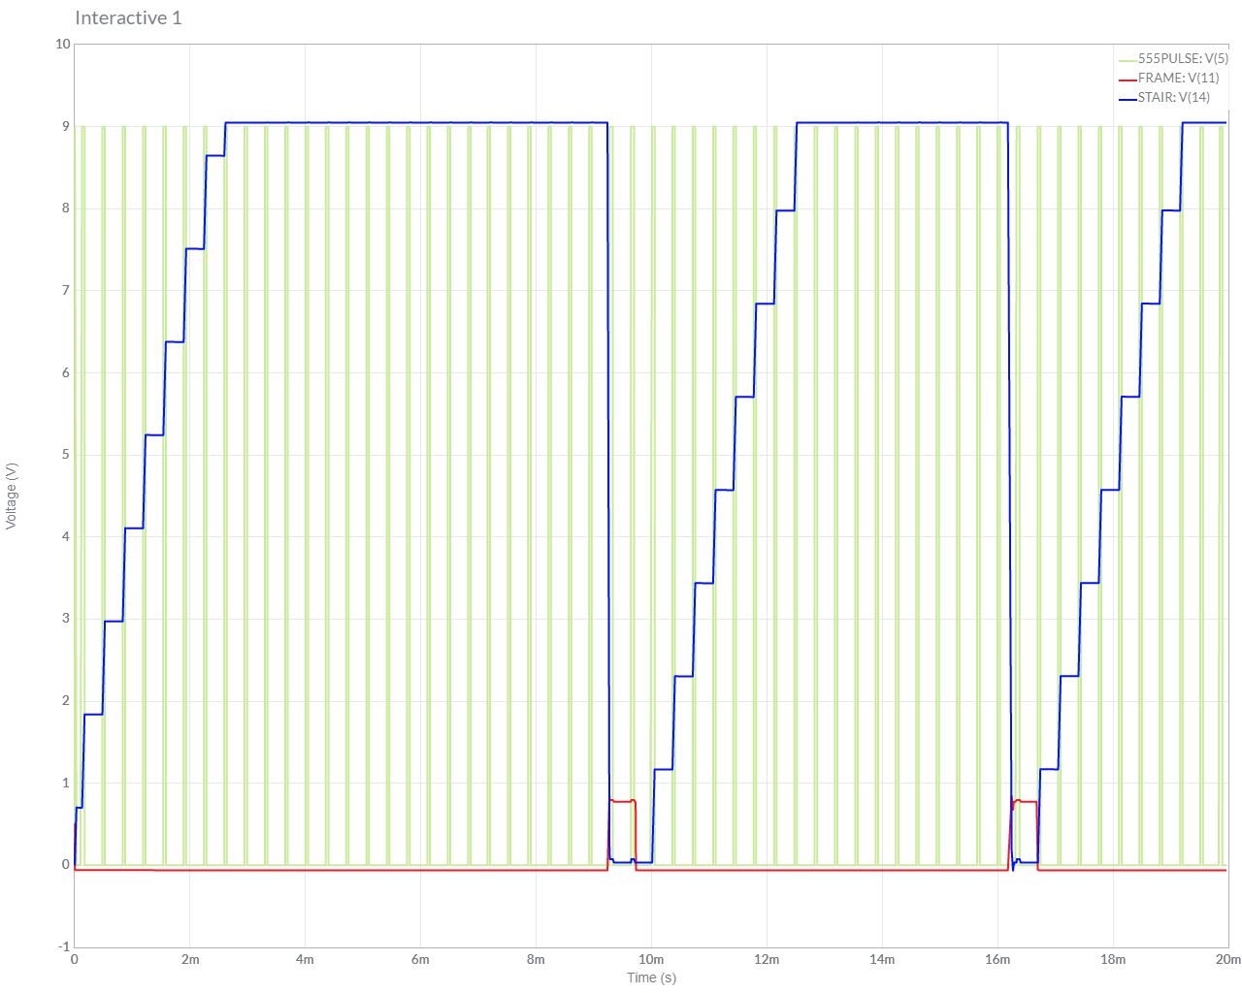

**Assemble Deboo Integrator**

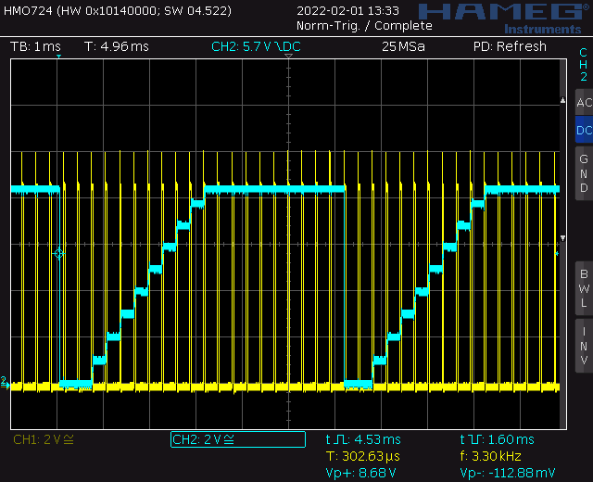

Note this oscilloscope trace was captures on a Rhode&Schwarz HMO724 using a 9V HP power supply. If you are getting all sorts of garbage into the 555TIMER signal then the student is probably using a AC/DC transformer, e.g. a wall wart.

**Assemble Deboo Integrator**

Screen shot oscilloscope output for 555PULSE and STAIR.

Table : Summary of the step size calculations made for the Deboo integrator.

|  |  |  |  |
| --- | --- | --- | --- |
| Quantity | Analysis | Simulation | Assemble |
| Step size | 1.03V | 1.14V | 0.98V |

|  |  |  |  |
| --- | --- | --- | --- |
| **Steps** | **Analysis** | **Simulation** | **Assemble** |
| 1 | 1.3V | 1.1V | 1.3V |
| 2 | 2.2V | 2.2V | 2.2V |
| 3 | 3.1V | 3.4V | 3.1V |
| 4 | 4.0V | 4.5V | 4.0V |
| 5 | 4.9V | 5.6V | 4.9V |
| 6 | 5.8V | 6.8V | 5.8V |
| 7 | 6.7V | 7.9V | 6.7V |
| 8 | 7.6V | 9V | 7.6V |
| 9 | 8.5V | 9V (sat) | 7.72 (sat) |
| 10 | 9.0V | 9V (sat) | 7.72 (sat) |